**Source Code Change Impact Analyzer**

**What is it:**

- The "Source Code Change Impact Analyzer" is a simple and intuitive desktop application that shows all the code/config files that will be impacted when a certain code/config file is changed. Just input the code/config file you are planning to change then the application will show you the code/config files who contains/ call it and the code/config files that contains/call the code/config files and so on and so fort, this is presented in an easy-to-visualize tree structure that gives the developer/programmer a bird’s-eye-view of all the code/config files affected. This is very helpful when debugging/understandig very complex application such as AllProfits where there are many interconnected and inter-related code/config files. Benefits of using the "Code Change Impact Analyzer": - It gives you a high level view of all the code/config files that will be impacted by your code change. - It helps in debugging and finding the critical code/config files you want to change. - But wait there’s more, it can also help in the code documentation. Supported code/config file formats: All text file formats such as jsp, txt, xml, jrxml, java, sql, etc…

**How to use:**

**A. First time to use (need to configure first). How to configure.**

1.) Open a command line as an Administrator, cd to the directory where the BubbleSearch.jar is located then run the BubbleSearch.jar thru the command line. The Source Code Change Impact Analyzer will launch (see screenshot below).

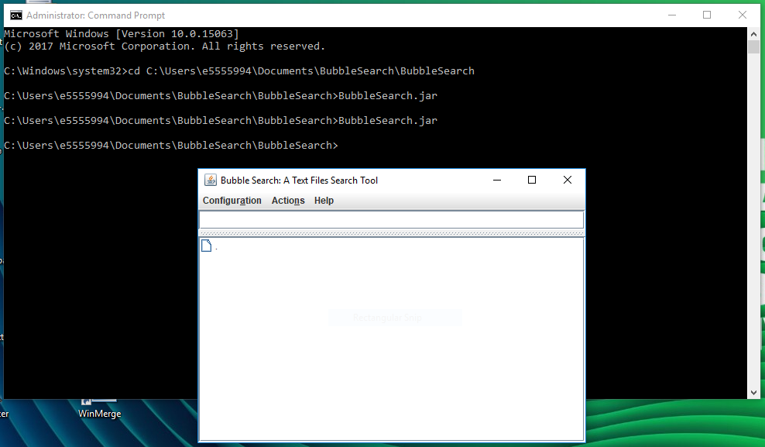

2.) Configure the index files directory by clicking “Configuration” >> “Index Files Directory”. Input where you want to put the index files.

3.) Configure the data files directory (this is where the source code files to be indexed are located. i.e. your “trunk” directory in AllProfits) by clicking “Configuration” >> “Data Files Directory”. Input where you want to put the data files.

4.) Configure the file formats to be indexed (this are the file formats that are included in the indexing) by clicking “Configuration” >> “File Formats To Be Indexed”. Input the following (without the double quotes): “sql,jsp,xml,jrxml,java,js,css”.

5.) Configure the file with included extension in the search (this are the file formats that you must include the file extension in the search input box in order for the search to be successful. i.e. PSMain.jsp) by clicking “Configuration” >> “File With Included File Extension In the Search”. Input the following (without the double quotes): “jsp,js,css”.

**Note:** “program.properties” will be auto-generated in the same directory after a configuration is saved/added.

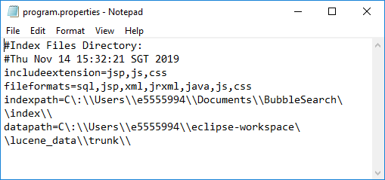

**B. After successful configuration, you will now need to index the source code files. This is a prerequisite before searching. If there is a change in one of the source code files you want to include in the search then you have to re-index.**

1.) Click “Actions” >> “Index Files” then wait for the prompt that the indexing is complete.

**C. Searching. After configuration and indexing, you may now start searching for keywords.**

1.) Input a keyword you want to search in the search input box then press “Enter”. There will be a prompt, just click “OK”. In the example below, you want to search all the files that have “PSMain.jsp” in it.

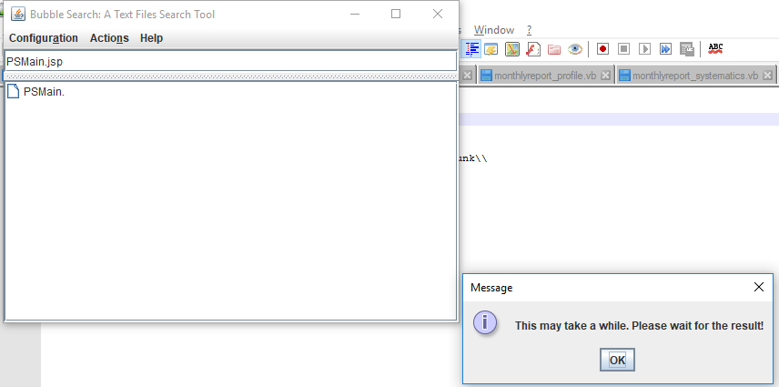

2.) After the search is complete, it will display the search result below the search input box in a tree structure format (see screenshot below). You can click the tree node to open the files. In the search result.

**How to interpret the result:** in the example below, the “PSMain.jsp” word/string is can be found in the following files: “PSMain.jsp“, “TransactionTF.xml“ and “TransactionPresentationModel.java“. The “TransactionPresentationModel.java“ word/string is then can be found in “TransactionPresentationContainer.java“ which is then can be found in “WeServConfigBootstrap.java“.

